*Forward Kinematics of Programmable Universal Manipulation Arm (PUMA) Robot Using Denavit-Hartenberg Representation*

*MECE 617 Activity*

Ivan John A. Naparota

University of San Carlos – Talamban Campus

Department of Electrical and Electronics Engineering

ivanjohnnaparota66@gmail.com

***Abstract* — this activity presents the Forward Kinematics of a Programmable Universal Manipulation Arm (PUMA) Robot using Denavit – Hartenberg Representation and with the aid of a numerical computing software, MATLAB.**

***Keywords* – *Forward Kinematics, Denavit-Hartenberg Representation, MATLAB***

# I. INTRODUCTION

Denavit–Hartenberg parameters (also called DH parameters) are the four parameters associated with a particular convention for attaching reference frames to the links of a spatial kinematic chain, or robot manipulator. Jacques Denavit and Richard Hartenberg introduced this convention in 1955 in order to standardize the coordinate frames for spatial linkages [2].

You just have to identify the parameters on each joint that is very needed in this convention, this will be defined further in the next parts of this paper. These parameters will then be used to perform the necessary operations that mainly involves multiplication of matrices for us to be able to obtain the position vector of the end effecter, which is the main concern of forward kinematics.

# II. EQUATIONS AND MATLAB CODES

#### A. Formulas and Equations

For a specific *i*, we obtain the T matrix, T = 0A*i*, which specifies the position and orientation of the endpoint of the manipulator with respect to the base coordinate system. Considering T matrix to be of the form [1]

T = $\left[\begin{matrix}cosθ & -cosαsinθ & sinαsinθ & acosθ \\ sinθ & cosαcosθ & -sinαcosθ & asinθ \\ 0 & sinα & cosα & d \\ 0 & 0 & 0 & 1\end{matrix}\right]$

Where:

d – depth along the previous joint’s z axis

θ – angle about the previous z to align its x with the new origin

r – distance along the rotated x axis

α – rotation about the new x axis to put z in its desired orientation

See figure 2,

According to page 37 of the book “Robotics: Control, Sensing, Vision, and Intelligence” by Fu, Gonzalez, and Lee, established link coordinate systems for PUMA robot is hereby presented:

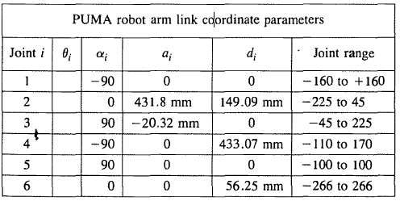

And θ’s depend on the inputs of the joints that will dictate the position of the end effecter.

Therefore,

Joint 1 = $\left[\begin{matrix}cosθ & -cos⁡(-90)sinθ & sin⁡(-90)sinθ & 0*cosθ \\ sinθ & cos⁡(-90)cosθ & -sin⁡(-90)cosθ & 0*sinθ \\ 0 & sin⁡(-90) & cos⁡(-90) & 0 \\ 0 & 0 & 0 & 1\end{matrix}\right]$

Joint 2 = $\left[\begin{matrix}cosθ & -cos⁡(0)sinθ & sin⁡(0)sinθ & 431.8*cosθ \\ sinθ & cos⁡(0)cosθ & -sin⁡(0)cosθ & 431.8*sinθ \\ 0 & sin⁡(0) & cos⁡(0) & 149.09 \\ 0 & 0 & 0 & 1\end{matrix}\right]$

Joint 3 = $\left[\begin{matrix}cosθ & -cos⁡(90)sinθ & sin⁡(90)sinθ & -20.32*cosθ \\ sinθ & cos⁡(90)cosθ & -sin⁡(90)cosθ & -20.32*sinθ \\ 0 & sin⁡(90) & cos⁡(90) & 0 \\ 0 & 0 & 0 & 1\end{matrix}\right]$

Joint 4 = $\left[\begin{matrix}cosθ & -cos⁡(-90)sinθ & sin⁡(-90)sinθ & 0*cosθ \\ sinθ & cos⁡(-90)cosθ & -sin⁡(-90)cosθ & 0*sinθ \\ 0 & sin⁡(-90) & cos⁡(-90) & 433.07 \\ 0 & 0 & 0 & 1\end{matrix}\right]$

Joint 5 = $\left[\begin{matrix}cosθ & -cos⁡(90)sinθ & sin⁡(90)sinθ & 0*cosθ \\ sinθ & cos⁡(90)cosθ & -sin⁡(90)cosθ & 0*sinθ \\ 0 & sin⁡(90) & cos⁡(90) & 0 \\ 0 & 0 & 0 & 1\end{matrix}\right]$

Joint 6 = $\left[\begin{matrix}cosθ & -cos⁡(0)sinθ & sin⁡(0)sinθ & 0*cosθ \\ sinθ & cos⁡(0)cosθ & -sin⁡(0)cosθ & 0*sinθ \\ 0 & sin⁡(0) & cos⁡(0) & 56.25 \\ 0 & 0 & 0 & 1\end{matrix}\right]$

And the homogeneous matrix 0T*i* which specifies the location of the *i*th coordinate frame with respect to the base coordinate system is the chain product of successive coordinate transformation matrices of i-1Ai, and is expressed as [1]

0Ti = 0A1 1A2 . . . i-1Ai =

Where:

P – Position vector of the hand

#### B. MATLAB Codes

clc;

clear all

close all

%depth

d1 = 0;

d2 = 149.09;

d3 = 0;

d4 = 433.07;

d5 = 0;

d6 = 56.25;

%alpha

a1 = -90;

a2 = 0;

a3 = 90;

a4 = -90;

a5 = 90;

a6 = 0;

%length

l1 = 0;

l2 = 431.8;

l3 = -20.32;

l4 = 0;

l5 = 0;

l6 = 0;

%theta

theta1 = 'Provide Angle Theta for Joint 1: ';

theta2 = 'Provide Angle Theta for Joint 2: ';

theta3 = 'Provide Angle Theta for Joint 3: ';

theta4 = 'Provide Angle Theta for Joint 4: ';

theta5 = 'Provide Angle Theta for Joint 5: ';

theta6 = 'Provide Angle Theta for Joint 6: ';

t1 = input(theta1);

t2 = input(theta2);

t3 = input(theta3);

t4 = input(theta4);

t5 = input(theta5);

t6 = input(theta6);

%transformation matrices

transformation1 = [cosd(t1) -(cosd(a1)*sind(t1)) sind(a1)*sind(t1) l1*cosd(t1)

sind(t1) cosd(a1)*cosd(t1) -(sind(a1)*cosd(t1)) l1*sind(t1)

0 sind(a1) cosd(a1) d1

0 0 0 1];

transformation2 = [cosd(t2) -(cosd(a2)*sind(t2)) sind(a2)*sind(t2) l2*cosd(t2)

sind(t2) cosd(a2)*cosd(t2) -(sind(a2)*cosd(t2)) l2*sind(t2)

0 sind(a2) cosd(a2) d2

0 0 0 1];

transformation3 = [cosd(t3) -(cosd(a3)*sind(t3)) sind(a3)*sind(t3) l3*cosd(t3)

sind(t3) cosd(a3)*cosd(t3) -(sind(a3)*cosd(t3)) l3*sind(t3)

0 sind(a3) cosd(a3) d3

0 0 0 1];

transformation4 = [cosd(t4) -(cosd(a4)*sind(t4)) sind(a4)*sind(t4) l4*cosd(t4)

sind(t4) cosd(a4)*cosd(t4) -(sind(a4)*cosd(t4)) l4*sind(t4)

0 sind(a4) cosd(a4) d4

0 0 0 1];

transformation5 = [cosd(t5) -(cosd(a5)*sind(t5)) sind(a5)*sind(t5) l5*cosd(t5)

sind(t5) cosd(a5)*cosd(t5) -(sind(a5)*cosd(t5)) l5*sind(t5)

0 sind(a5) cosd(a5) d5

0 0 0 1];

transformation6 = [cosd(t6) -(cosd(a6)*sind(t6)) sind(a6)*sind(t6) l6*cosd(t6)

sind(t6) cosd(a6)*cosd(t6) -(sind(a6)*cosd(t6)) l6*sind(t6)

0 sind(a2) cosd(a2) d6

0 0 0 1];

%multiply

multiply1 = transformation1 * transformation2;

multiply2 = transformation1 * transformation2 * transformation3;

multiply3 = transformation1 * transformation2 * transformation3 * transformation4;

multiply4 = transformation1 * transformation2 * transformation3 * transformation4 * transformation5;

multiply = transformation1 * transformation2 * transformation3 * transformation4 * transformation5 * transformation6;

%output

output = [multiply(1,4) multiply(2,4) multiply(3,4)]';

disp('End Effecter is Located on Point(x,y,z):');

disp(num2str(output,'%.2f'))

%plot

line([0 0],[0 0],[-660.4 0],'LineWidth',2)

line([0 multiply1(1,4)],[0 multiply1(2,4)],[0 0],'LineWidth',2, 'color','r');

line([multiply1(1,4) multiply2(1,4)],[multiply1(2,4) multiply2(2,4)],[0 multiply2(3,4)],'LineWidth',2, 'color','g')

line([multiply2(1,4) multiply3(1,4)],[multiply2(2,4) multiply3(2,4)],[multiply2(3,4) multiply3(3,4)],'LineWidth',2, 'color','y')

line([multiply3(1,4) multiply4(1,4)],[multiply3(2,4) multiply4(2,4)],[multiply3(3,4) multiply4(3,4)],'LineWidth',2, 'color','b')

line([multiply4(1,4) multiply(1,4)],[multiply4(2,4) multiply(2,4)],[multiply4(3,4) multiply(3,4)],'LineWidth',2, 'color','k')

axis([-1000 1000 -1000 1000 -1000 1000])

grid on

%message

disp('Type [PumaForwardDH] in Command Window to Try Again');

IV. RESULTS AND DISCUSSIONS

As shown in Figure 1, the program will ask for the input thetas that will define the position of the end effecter of our PUMA robot, thetas are the only inputs we have because the other parameters are already defined as shown above.

For these given thetas,

Theta for Joint 1: 90

Theta for Joint 2: 0

Theta for Joint 3: 90

Theta for Joint 4: 0

Theta for Joint 5: 0

Theta for Joint 6: 0

And considering the defined parameters presented above,

End effecter is located in (x,y,z) point (-149.09, 921.12, 20.32).

To verify if the presented end effecter of the program is correct, refer to page 45 of the book “Robotics: Control, Sensing, Vision, and Intelligence” by Fu, Gonzalez, and Lee,

*“As a check, if θ1 =90', θ2 =0', θ3 =90', θ4 = 00, θ5 =0', θ6 =0', then the T matrix is”* 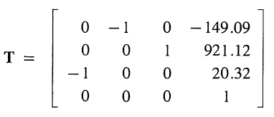

This validates the end effecter presented by the program.

V. CONCLUSION

Denavit – Hartenberg representation is capable of solving the forward kinematics of Programmable Universal Manipulation Arm (PUMA) robot, you just have to define the parameters on each joint of the PUMA robot and do the necessary operations that mainly involve multiplication of matrices.

Also, MATLAB’s computing prowess would help a lot to perform the necessary operations without the need for manual solutions.

VI. REFERENCES

1. Fu, K. S., Gonzales, R. C., .Lee, C. S. G., ROBOTICS : Control, Sensing, Vision, and Intelligence.
2. https://en.wikipedia.org/wiki/Denavit%E2%80%93Hartenberg_parameters

VII. FIGURES

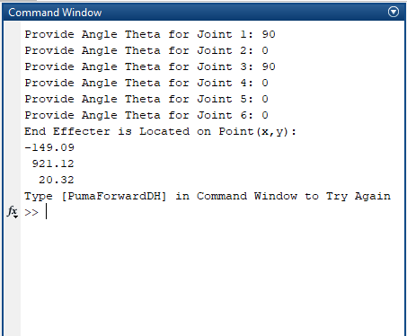

Figure 1MATLAB Command Window

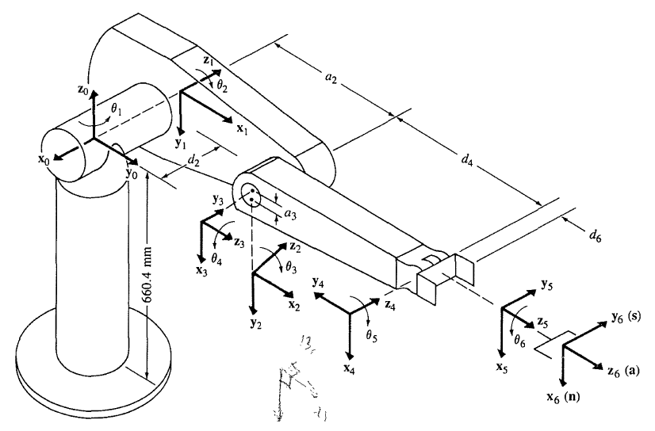

Fu, K. S., Gonzales, R. C., .Lee, C. S. G., ROBOTICS : Control, Sensing, Vision, and Intelligence.

Figure 2 PUMA Robot

##### 